Sherington Primary
School
Aspire, Believe, Create, Achieve

Calculation Policy for Mathematics

This calculation policy sets out the methods used to help our pupils with calculations and has been devised to meet requirements of the National Curriculum 2014 for the teaching and learning of mathematics. It is also designed to give pupils a consistent and smooth progression of learning in calculations across the school, taking into account Maths No Problem! - a Singaporean teaching style in Maths.

The end of year expectations (of which this calculation policy aims to meet) are provided in homework books, displayed around classrooms, used by pupils in their Learning Journeys, and by teachers via Learning Ladders.

Pupils are taught strategies to develop and strengthen their mental agility on a daily basis. They also need to be able to apply written calculation skills in order to:
- represent work that has been done practically
- support, record and explain mental calculation
- keep track of steps in a longer task
- work out calculations that are too difficult to do mentally

The Calculation Policy shows methods that pupils will be taught within their respective year group. It is shown in teaching order. Children should be confident in choosing and using a strategy that they know will get them to the correct answer as efficiently as possible; pupils are free to choose their preferred method to solve calculations.

Concrete, Visual, Abstract:
A key principle behind the Singapore Maths textbooks and Maths Mastery is based on the concrete, visual and abstract approach. Pupils are first introduced to an idea or skill by acting it out with real objects (a hands- on approach). Pupils then are moved onto the visual stage, where pupils are encouraged to relate the concrete understanding to pictorial representations. The final abstract stage is a change for pupils to represent problems by sing mathematical notion. Whilst this calculation policy aims to show the CVA approach to the different calculations, it is not always noted further up the year groups. However, it is expected that the CVA approach is used continuously in all new learning and calculations even when not noted.

In EYFS pupils should be developing their concept of the number system through the use of concrete materials and pictorial representations. They should experience practical calculation opportunities using a wide variety of equipment, e.g. small world play, role play, counters, cubes etc. They develop ways of recording calculations using pictures, etc.

Addition: Add two single digit numbers, counting on to find the answer.
Pupils must be provided with opportunities to develop their skills so that they are able to count reliably, including one to one correspondence and count on from a given number.
Pupils should be given the opportunity to count out sets of objects and then combine them to make a total e.g. 6 + 2 = 8
First count out a group of
6. Then count out a group of 2. Finally combine them to find a total.

Pupils should recognise different ways of making numbers. E.g 6 can be made as
6
6
0

Subtraction: Using quantities and objects, subtract two single-digit numbers and count back to find the answer.

Pupils should count out a group of objects, move some away and recount the total.
8 – 3 = 5
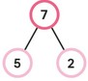
After pupils have recognised different ways of making numbers, they should use this number bond knowledge to help with subtraction facts.

Children should use concrete materials to start counting back in order to solve subtraction problems.
8 – 3 =
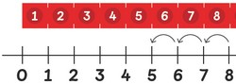

Multiplication: Solve problems, including doubling

Children will experience equal groups of objects. They should work on practical problem solving activities.
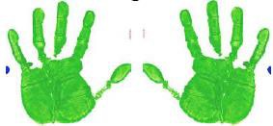

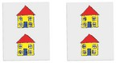
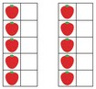
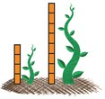
Use a range of concrete materials to show a number and then repeat the number to show doubling. Then move onto pictorial representations.

Division: Solve problems, including halving and sharing

Pupils should have many practical experiences of sharing objects e.g. sharing between 2 people, or finding ½ of a group of objects.
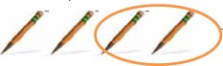

Use a range of concrete materials to show a number and then share them equally. Then move onto pictorial representations.
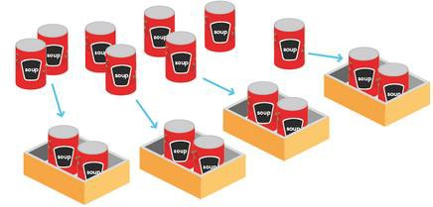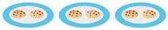

Addition: Add one-digit and two-digit numbers to 20, including zero

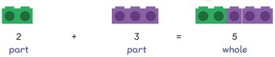
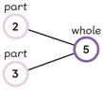
Use objects to count on and add by using number bonds.
Use numbered number lines to add, by counting on in ones. Encourage children to start with the larger number and count on. +1 +1 +1
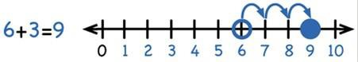
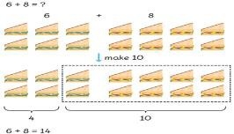
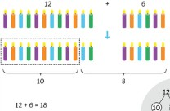Add by using number bond knowledge in order to make 10 / add the ones.

Introduce to the bar method. Use visual bars to show the calculation. 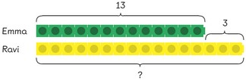

Subtraction: Subtract one-digit and two-digit numbers to 20, including zero

Building on from the EYFS methods, children consolidate understanding of subtraction practically. Use physical objects to count back, which is then reinforced on different number squares and number lines.
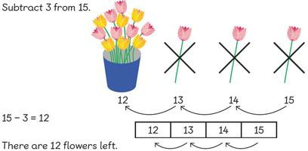

Pupils use knowledge of place value to partition 2 digit numbers in order to subtract ones from the number. They will be exposed to language such as “How much more” and “What is the difference between”.
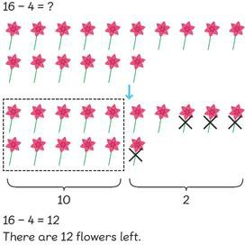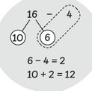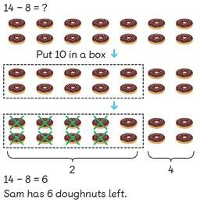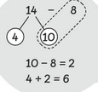

Pupils will be exposed to the idea of commutativity to understand the idea of fact families.
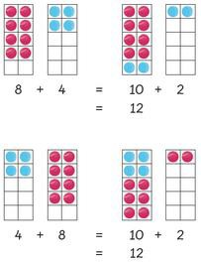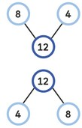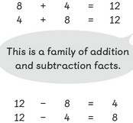

Children should start recalling subtraction facts up to and within 10 and 20, and should be able to subtract zero.

Multiplication: Solve one-step problems involving multiplication by calculating the answer using concrete objects, pictorial representations and arrays

Children should practise making equal groups first and add them to associate repeated addition with multiplication. Use a range of concrete materials before pictorial representations.
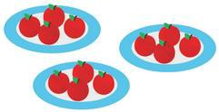
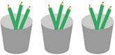

Associate grouping to equal rows so children learn to count up in the same number.
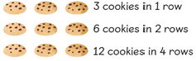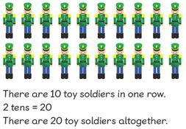

Division: Solve one-step problems involving division by calculating the answer using concrete objects, pictorial representations and arrays

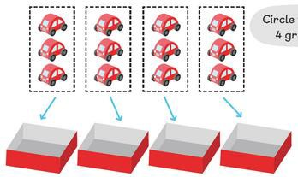Building on multiplication knowledge and EYFS division strategies, children practise grouping concrete objects equally in order to count the amount in teach group. Use a range of concrete materials before pictorial representations.

Build on practical materials by sharing and moving objects.
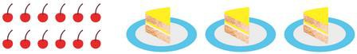

Addition: Add with 2-digit numbers

Before moving onto the written method, children should add using a range of resources and methods.
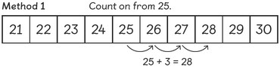
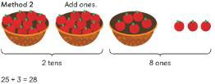
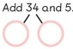
Use a range of resources to add and associate to a written method (column method)
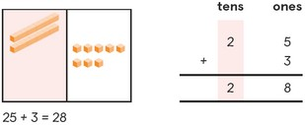
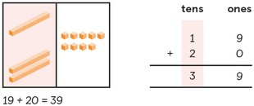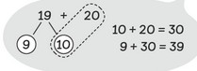Use knowledge of number bonds to add numbers

When renaming, show the expanded method, but link straight to the compact method.
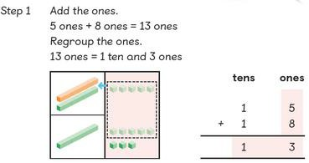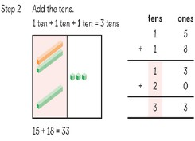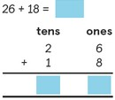
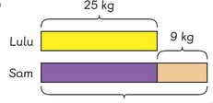
Children should use bars as a visual model to solve addition calculations and exposed to word problems.

Subtract: Subtract with 2-digit numbers

Before moving onto the written method, children should add using a range of resources and methods, including using knowledge of number bonds to subtract numbers.
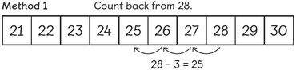
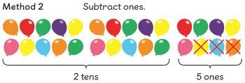
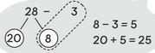

Use knowledge of subtraction to take away groups of 10.
4 – 1 = 30 therefore 40 – 10 = 30.

Use a range of resources to add and associate to a written method (column method)
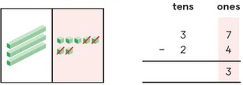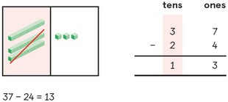
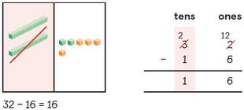
When renaming, you subtract the ones first, and then cross out the number you need to rename and write new number on top.

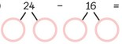
Use knowledge of number bonds to subtract.

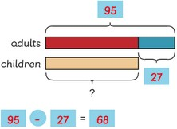
Children should use bars as a visual model to solve subtraction calculations and exposed to word problems.

Multiplication: Calculate mathematical statements and solve problems for multiplication within the multiplication tables (2, 5 & 10)

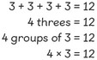
. Begin with consolidating Year 1 repeated addition and associate to multiplication.

Before moving onto the written method, children should add using a range of resources and methods
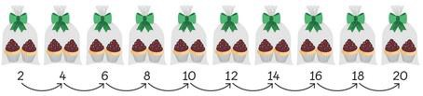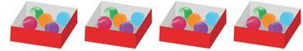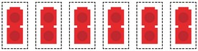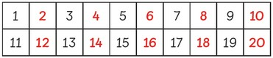

Children will associate the law of commutativity to multiplication using arrays and practical resources to show.
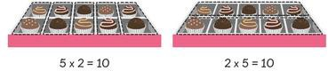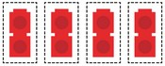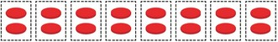

Move onto abstract route with problems.
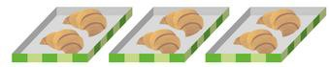

Division: Calculate mathematical statements and solve problems for division within the multiplication tables (2, 5 & 10)

Build on Year 1 by consolidating grouping equally. Use a range of resources to show division.

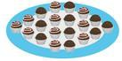Work on each times table in order (2, 5 then 10). Use idea of grouping before show division and link to the abstract calculation with the ÷ sign.

20 ÷ 2 = 10

Associate to the law of commutativity to show link between multiplication and division.

Work through CPA approach.
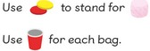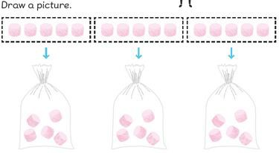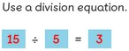

Addition: Add numbers with 3 digits
Introduce the expanded column method first using manipulatives first.
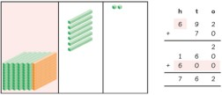
Add the ones first in preparation for the compact method.

Introduce addition with renaming using the compact method with manipulatives first. Show how to rename, with partitioning.
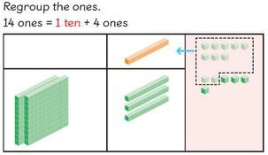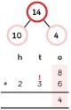
- Add the ones first.
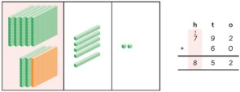
- Carry the numbers directly above the next number, ensuring that the carried number is recorded first.
- The + symbol is positioned to the left, away from the digits

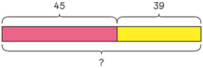
Continue to use bars as a visual model to solve addition calculations and exposed to word problems.

Subtraction: Subtract numbers with 3 digits
Children should use mental strategies to subtract 1 digit numbers and multiples of 10 from 3 digit numbers.

Introduce subtraction with renaming using the compact method with manipulatives first. Show how to rename, with partitioning.
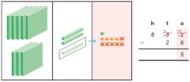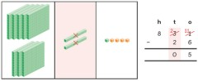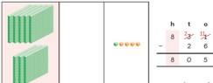
- Subtract the ones first.
- Cross out a number which needs renaming and write the new number directly on top.
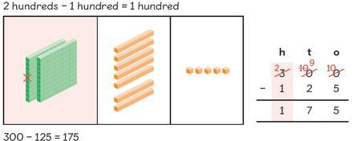
- The - symbol is positioned to the left, away from the digits Carry on, introducing multi-step renaming in single calculations.

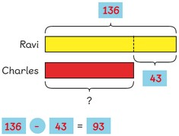
Continue to use bars as a visual model to solve subtraction calculations and exposed to word problems.

Multiplication: Multiply 2-digits by a single digit number
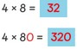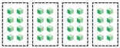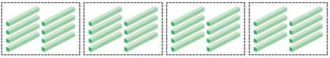Introduce by applying already known knowledge to multiples of 10. Use a range of manipulatives to show.
Consolidate repeated addition before moving onto multiplication of 2 digit numbers.
- Multiply the ones digit by the single-digit number
- Multiply the tens digit by the single-digit number
Show partition to show how this looks, using manipulatives as a supporting mechanism. Show column method alongside.
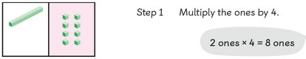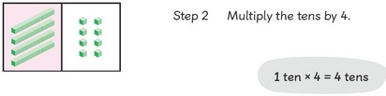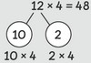

Show expanded method for conceptual understanding, but move straight onto the compact method using same techniques and break-downs.
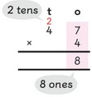
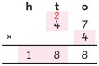
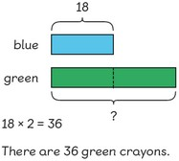
When regrouping, always start with the larger value and write on top of the next digit.

Continue to use CPA approach and visual bars when solving multiplication and division in word problems.

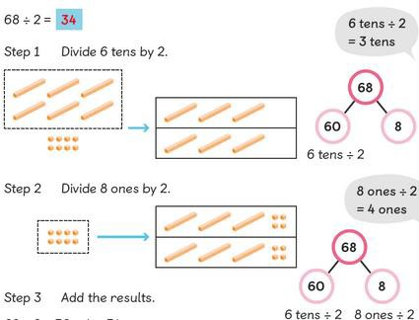
Division: Divide 2-digit numbers by a single digit (where there is no remainder in the final answer)
Introduce division by using manipulatives to divide (working on times table in order – 2, 5, 10, 3, 4, 8). Show partitioning to link in division.

Show ‘chunking’ method of division, using known division facts to take away chunks. Also show ‘short division’ method and link 2
methods together.

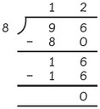

Continue to use CPA approach and visual bars when solving multiplication and division in word problems.
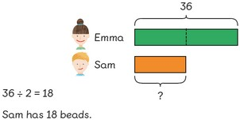

Addition: Add numbers with 4 digits

Reinforce column method by using concrete materials first
. 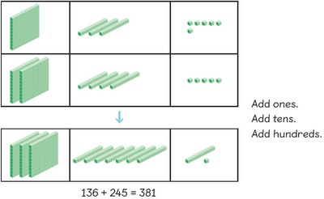 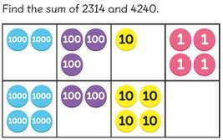
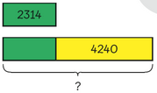
Move onto pictorial, using bar modelling.

Show expanded method to make link of place value. Move straight onto compact method. When renaming, the number is carried directly above the number.
Use concrete materials to show renaming.
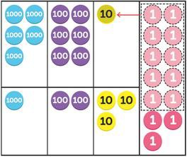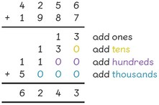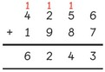

Subtraction: Subtract numbers with 4 digits
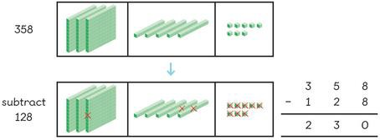
Reinforce column method by using concrete materials first, including for renaming.

Move onto pictorial, using bar modelling. 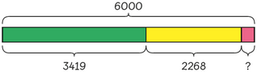
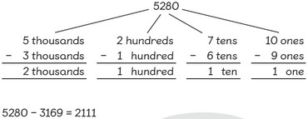
Show expanded method to make link of place value. Move straight onto compact method.
When renaming, the number is crossed out and rewritten directly above. Use concrete materials to show renaming.
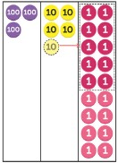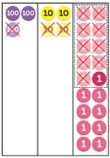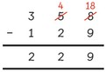

Multiplication: Multiply 2 and 3-digit numbers by a single digit, using all multiplication tables up to 12x12

Pupils should continue to develop their knowledge and understanding of multiplying by a single digit, using short multiplication (the formal written method of compact multiplication).
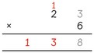
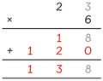
Show expanded method but move straight onto compact method, as in Year 3, to show why and how to regroup.

Use different CPA approaches to show the same calculation.
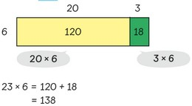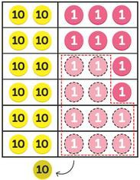

Pupils must be secure in multiplying a 2-digit number by a single digit, before moving onto 3-digit numbers. Repeat using same process as 2-digit numbers.
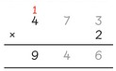
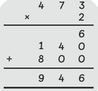
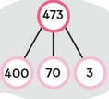
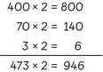

Division: Divide up to 3-digit numbers by a single digit
Pupils should continue to develop their knowledge and understanding of dividing by two-digits, using chunking and short division. Move onto 3-digit using same approach.
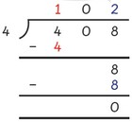
If there is a remainder, this should be noted after the quotient.
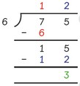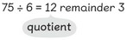

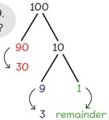Move onto 3-digit numbers divided by a single digit number after children are secure with 2-digit numbers. Use same concept; show chunking and short division, with CPA approach.
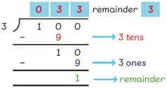

Addition: Add numbers with more than 4 digits

Carry on using previous methods taught in previous years to add, using the same terminology. Continue up to place value being taught.

When adding decimals, use place value counters to show addition and use when renaming.
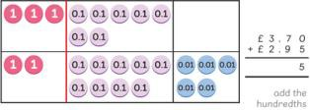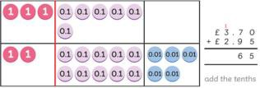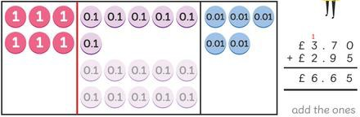

Subtraction: Subtract numbers with more than 4 digits

Carry on using previous methods taught in previous years to subtract, using the same terminology. Continue up to place value being taught.

When subtracting decimals, use place value counters to show subtraction and use when renaming
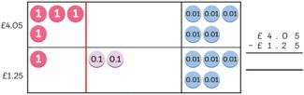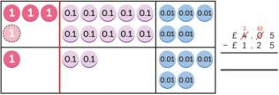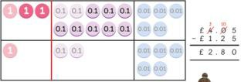

Multiplication: Multiply numbers up to / more than 4 digits (with decimals in Yr 6)

Carry on using previous methods taught in previous years to multiply, using the same terminology. Continue up to place value being taught. Start with 4 digits multiply by 1 digit before slowly adding further digit.
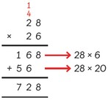

When multiplying decimals, use same method but ensure decimal point is in with all values carefully written, in line, on either side.
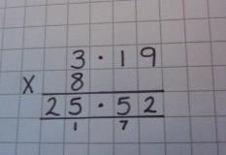

Division: Divide at least 4 digits by single-digit numbers (and 2-digit numbers in Yr 6)

Carry on using previous methods taught in previous years to divide, using the same terminology. Continue up to place value being taught. Start with 4 digits divide by 1 digit before slowly adding further digit.

Show chunking and short division method. When chunking, show partitioning as place value.
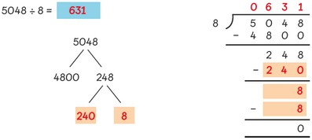
With remainders, continue with same method but replace new value with a crossing out. Put remainders as r and fraction. In year 6, show to continue with 0s after the decimal point.
